**Assisted Practice: 5.1 Install Kubernetes**

This section will guide you:

* To install Kubernetes on a standalone server in order to deploy a custom Docker container

This lab has mainly three subsections, namely:

5.1.1 Installing prerequisites packages

5.1.2 Configuring Kubernetes

5.1.3 Pushing the code to GitHub repositories

**Step 5.1.1:** Installing prerequisites packages

* Kubernetes is already installed in your practice lab. (Refer FSD: Lab Guide - Phase 5)
* Run the **docker version** command to validate Docker.

**docker version**

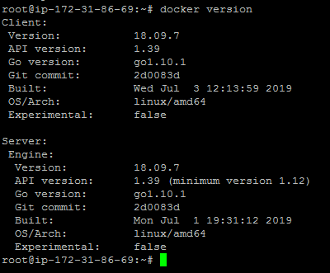

**Step 5.1.2:** Configuring Kubernetes

* Configure Kubernetes using the procedure below.

**curl -s https://packages.cloud.google.com/apt/doc/apt-key.gpg | apt-key add -**

**echo "deb http://apt.kubernetes.io/ kubernetes-xenial main" >/etc/apt/sources.list.d/kubernetes.list**

**apt-get update**

**apt-get install -y kubelet kubeadm kubectl**

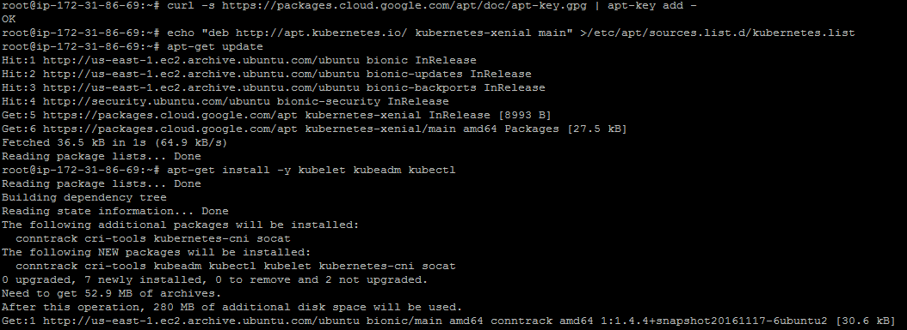

* Initialize Kubernetes to deploy containers using Kubernetes CLI.

**kubeadm init**

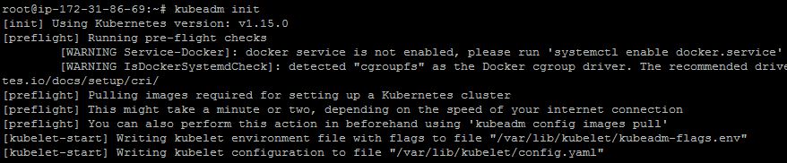

* Once Kubernetes is initialized, configure Kubernetes to start using the Kubernetes cluster.

**mkdir -p $HOME/.kube**

**sudo cp -i /etc/kubernetes/admin.conf $HOME/.kube/config**

**sudo chown $(id -u):$(id -g) $HOME/.kube/config**

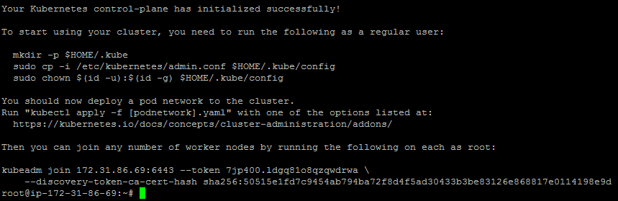

* After the cluster gets started, deploy a weave network to the cluster.

**export kubever=$(kubectl version | base64 | tr -d '\n')**

**kubectl apply -f "https://cloud.weave.works/k8s/net?k8s-version=$kubever"**

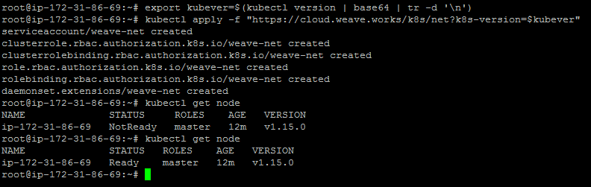

* With weave network deployment, validate that the node is up and running. That will help to deploy a Docker container to the Kubernetes cluster.

**kubectl get node**

**kubectl get pods --all-namespaces**

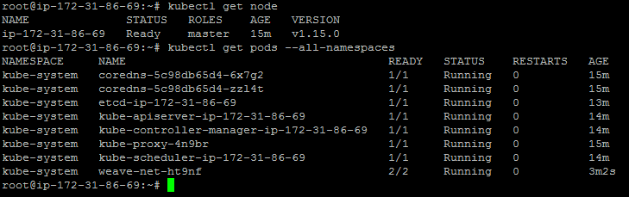

**Step 5.1.3:** Pushing the code to your GitHub repositories

* Open your command prompt and navigate to the folder where you have created your files.

**cd <folder path>**

* Initialize your repository using the following command:

**git init**

* Add all the files to your git repository using the following command:

**git add .**

* Commit the changes using the following command:

**git commit . -m “Changes have been committed.”**

* Push the files to the folder you initially created using the following command:

**git push -u origin master**